KENDRIYA VIDYALAYA CMERI, DURGAPUR
FUNDAY TIME TABLE

CLASS | 1st | 2nd | 3rd | 4th | R | 5th | 6th | 7th | 8th
I | ART  SD | ART  SB | FILM SHOW  SH | FILM SHOW  SH | E | MUSIC  SP | DANCE  SD | GAMES& YOGA  GB | GAMES& YOGA  SP
II | COMM ENG  PB | ART & CRAFT  SD | FILM SHOW  SH | FILM SHOW  SH | C | DANCE  SD | MUSIC  SP | GAMES& YOGA  GB | GAMES& YOGA  PB
III | MENTAL  MATHS  PK | MENTAL MATHS  RS | ART & CRAFT  PK | ART & CRAFT  PB | E | FILM SHOW  RS | FILM SHOW  SH | GAMES& YOGA  GB | GAMES& YOGA  PK
IV | COMM  ENG  SB | COMM  ENG  PK | ART & CRAFT  PB | ART & CRAFT  PK | S | FILM SHOW  RS | FILM SHOW  SH | GAMES& YOGA  GB | GAMES& YOGA  RS
V | COMM  ENG  RS | COMM ENG  PB | ART & CRAFT  RS | ART & CRAFT  RS | S | FILM SHOW  SB | FILM SHOW  SB | GAMES& YOGA  GB | GAMES& YOGA  SH

FUN DAY ACTIVITIES

ACTIVITY

COMMUNICATIVE ENGLISH

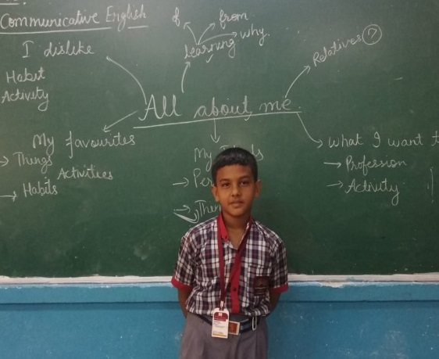 | 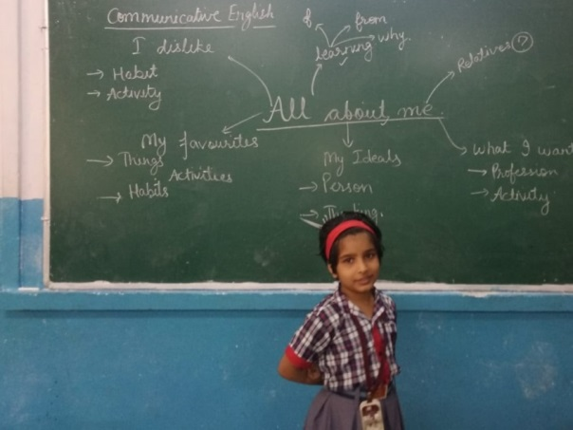
ART AND CRAFTS
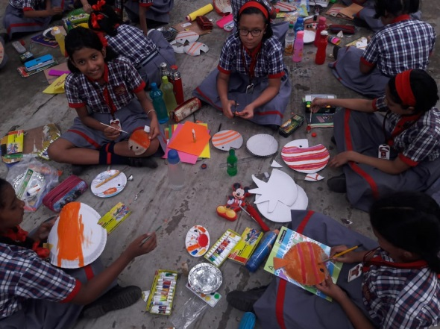 | 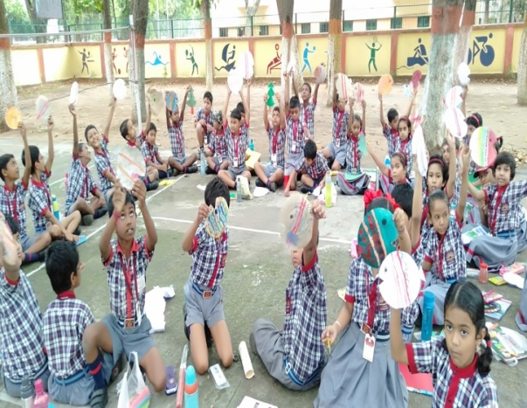

GAMES AND YOGA
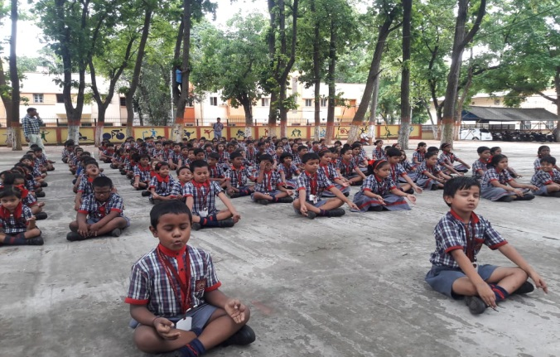 | 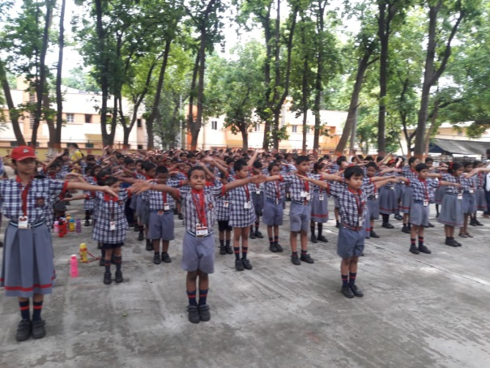

DANCE& MUSIC AND FLIM SHOW

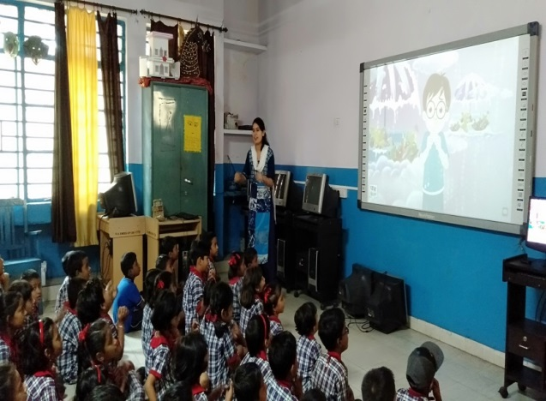 | 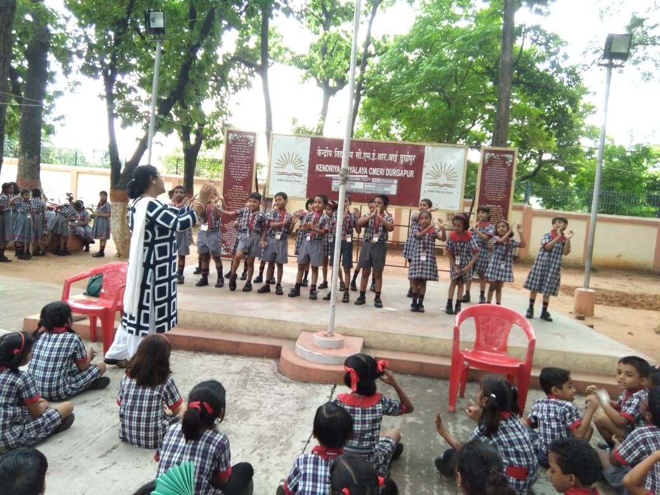

MASK MAKING
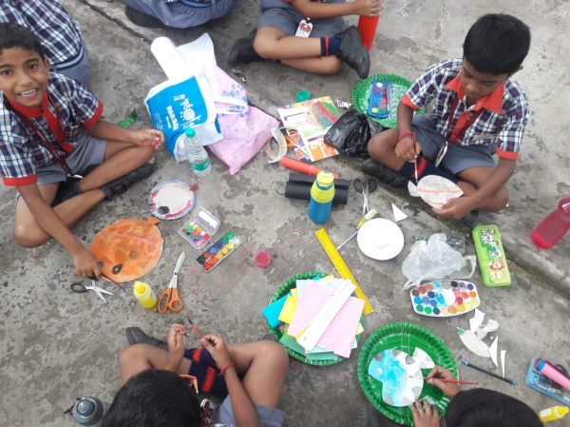 | 